# Project Title: Social Distancing Alert System

## Introduction:

1. Overview:

COVID-19 spread is emotionally challenging for many people, changing day-to-day life in unprecedented ways. All sections of society should play a vital role to protect themselves and each other and help prevent further spread of the disease. Social-distancing is an important way to slow down the spread of infectious diseases. People are asked to limit their interactions with each other, reducing the chances of the disease being spread with physical or close contact.

1. Purpose:

The purpose is to create a system that uses pre-installed cameras/ recorded videos to analyze images from public areas like shopping malls, streets to see whether the public is adhering to safety measures, like maintaining social distancing.This project uses python combined with deep learning and computer vision to monitor social distancing. A web application is built and is hosted on the cloud which streams the video of Social distancing Violations.

Result:

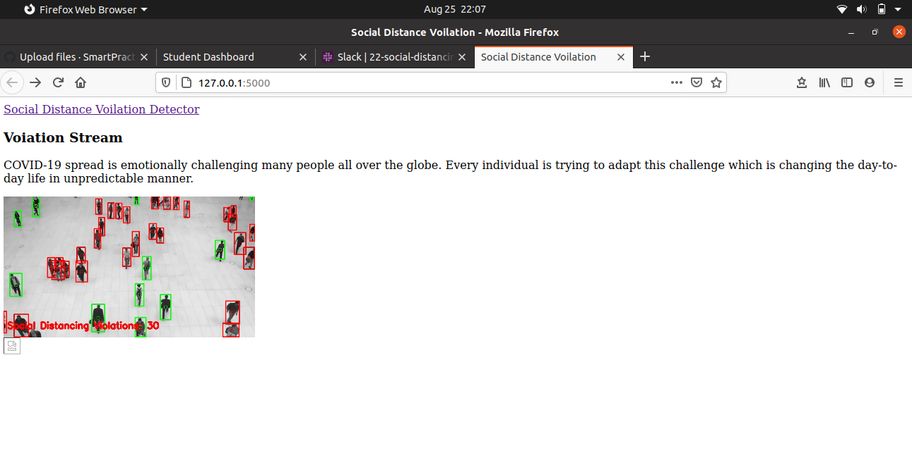

Applications:

* Modifying the application to make it available for the public can help people observe social distancing more effectively, stay safe and play a part in slowing down the infection rate of COVID-19.
* People who need to leave home to go to the supermarket or the pharmacy can check before they depart whether the shops are becoming crowded. If there are too many people, they can delay their trip until it’s less busy or switch to less-crowded shops nearby.

Conclusion:

Social-distancing is an important way to slow down the spread of infectious diseases. People are asked to limit their interactions with each other, reducing the chances of the disease being spread with physical or close contact.

Future Scope:

The application can be modified to a crowd checking application. People who need to leave home to go to the supermarket or the pharmacy can check before they depart whether the shops are becoming crowded. If there are too many people, they can delay their trip until it’s less busy or switch to less-crowded shops nearby.